Z80 Microprocessor
Godfrey Ouma
University of the People
CS 1105-01: Digital Electronics & Computer Architecture
Afrah Nazir
July 30, 2024

Z80 Microprocessor
Introduction
The Z80 microprocessor, developed by Zilog in the late 1970s, is renowned for its versatility and efficiency in executing instructions and handling interrupts. Its design supports a wide range of operations, including memory read/write, I/O device read/write, and interrupt acknowledgment, making it a powerful tool for embedded systems and various computational applications (Zilog, 2016). This document delves into the step-by-step process by which the Z80 executes instructions and manages interrupts, providing a detailed explanation supported by diagrams from the Z80 CPU User Manual.
Executing Instructions and Handling Interrupts
The Z80 microprocessor executes instructions by following a systematic approach involving several steps: memory read/write operations, I/O device read/write operations, and interrupt acknowledgment (Zilog, 2016). Below is a detailed step-by-step explanation of how the Z80 microprocessor executes instructions and handles interrupts, justified with relevant diagrams from the attached documents.
Step-by-Step Execution of Instructions
Overall, the Z80 processor follows a fetch-decode-execute cycle to read instructions from memory, perform the necessary operations, and move to the next instruction, enabling the execution of programs and the manipulation of data.
- Fetch Cycle:
The Z80 fetches the opcode from memory. This involves placing the program counter (PC) on the address bus, reading the opcode from memory, and incrementing the PC (Zilog, 2016).
Figure 1:
Instruction Op Code Fetch
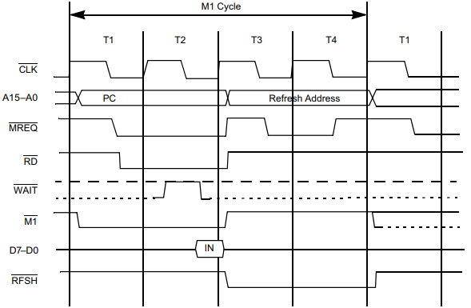
Source: Zilog, 2016.
- Decode Cycle:
The Control Unit decodes the instruction in the IR to determine the type of operation and the required operands. The decoding process involves looking up the opcode in the instruction set and setting up the necessary control signals for the execution phase (Zilog, 2016).
- Execute Cycle:
The Z80 CPU executes instructions through a series of basic operations like reading/writing to memory or I/O devices, and handling interrupts. Each instruction is composed of multiple of these operations (Zilog, 2016). These operations take place in specific time units called T cycles. Multiple T cycles form a machine cycle (M cycle). The first M cycle of any instruction is always a fetch cycle to retrieve the next instruction from memory. Subsequent M cycles handle data transfer between the CPU and memory or I/O devices. Both T and M cycles can be extended to synchronize the CPU with slower external devices (Zilog, 2016).
Figure 2:
Basic CPU Timing Example
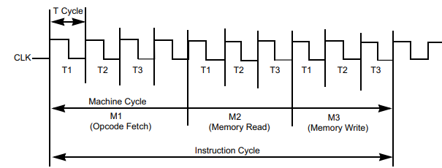
Source: Zilog, 2016.
Handling Interrupts
The Z80 supports multiple interrupt modes, allowing flexibility in how interrupts are managed (Zilog, 2016). Here's how the Z80 handles interrupts step-by-step:
- Interrupt Request (INT):
When an interrupt request is received, the CPU completes the current instruction before acknowledging the interrupt.
Figure 3:
Interrupt Request/Acknowledge Cycle
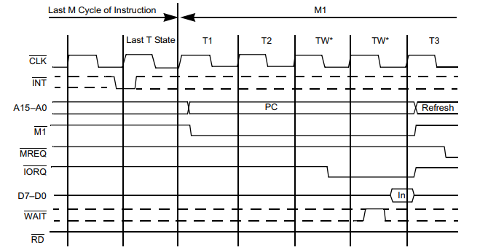
Source: Zilog, 2016.
- Interrupt Acknowledge Cycle:
The CPU acknowledges the interrupt request by sending an Interrupt Acknowledge (INTA) signal. For non-maskable interrupts (NMI), the CPU directly jumps to the NMI service routine (Zilog, 2016).
Figure 4:
Non-maskable Interrupt Request Operation
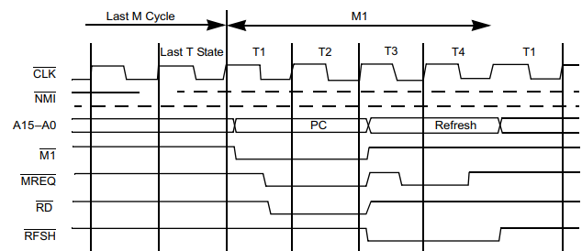
Source: Zilog, 2016.
- Interrupt Modes:
  - Mode 0: The interrupting device provides instructions to be executed.
  - Mode 1: The CPU executes a restart (RST) instruction to a fixed address (0038h).
  - Mode 2: The CPU uses a vector supplied by the interrupting device to jump to an interrupt service routine (ISR).
Figure 5:
Mode 2 Interrupt Response Mode
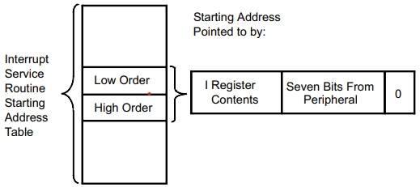
Source: Zilog, 2016.
- Execution of ISR:
In Mode 2, the CPU forms a 16-bit address using the contents of the Interrupt Vector Register (I) and the data supplied by the interrupting device. This address points to the ISR location (Zilog, 2016).
- Return from Interrupt:
After the ISR execution, the CPU returns to the main program using the Return from Interrupt (RETI) or Return from Non-maskable Interrupt (RETN) instructions (Zilog, 2016).
- Restoring the State:
After completing the ISR, the CPU restores the saved state (PC and flags) from the stack. The CPU resumes executing the main program from where it was interrupted (Zilog, 2016).
Significance of interrupt handling in the Z80 microprocessor
Interrupt handling in the Z80 microprocessor is significant as it allows the system to respond to peripheral events without relying on manual polling. The Z80 microprocessor supports three interrupt modes: 0, 1, and 2. In interrupt modes 0 and 2, the Z80 executes specific instructions or jumps to a specific address when an interrupt occurs (Cook, 2015). However, mode 1 is recommended for simplicity, where the Z80 jumps to a specific address (0038h) and runs a routine that the programmer implements. This routine should follow certain guidelines, such as saving and restoring registers, enabling interrupts, and using the RET instruction to exit the routine (Cook, 2015). Even though it can be a bit complicated to implement, using interrupts provides a flexible way to handle peripheral events, ensures smooth operation, and avoids the need for slow manual polling.
Conclusion
The Z80 microprocessor is a robust and versatile component in the realm of computing, capable of efficiently executing instructions and managing interrupts through a structured approach involving fetch, decode, and execute cycles. Its ability to handle interrupts in multiple modes provides flexibility and ensures prompt responses to peripheral events, enhancing the overall performance of embedded systems. The detailed understanding of its operational steps, as illustrated with relevant diagrams from the Z80 CPU User Manual, underscores the processor's significance in both historical and contemporary contexts.
References
Cook M. (2015, April 15). Z80 interrupts. Z80 Journal. https://z80journal.wordpress.com/2015/04/15/z80-interrupts/
Zilog. (2016). Z80 Microprocessors: Z80 CPU User Manual. https://www.zilog.com/docs/z80/um0080.pdf

